REQUEST FOR QUOTATIONs (RFQ)

Date: June 04,2024 Ref No.: FY24-RFQ-0000023

Supplier/Service Provider: ------------------------------------------------------------------------

RFQ launch date: | June 4th, 2024
Deadline for quotation submission: | June 10th, 2024
Quotation submitted to: | Tel: +249 (0) 183 231 905 / 6  Mobile: +249(0) 900905225  Ahmed.Ibrahim@plan-international.org
Purchase Requisition Number | PR24/0000

Plan international Sudan invites you to submit a quote in accordance with the requirement of the request for quotation. Quotes must be received no less than the date stated above for the following items:

Port Sudan Office Networking Items for Quotation
No. | Items | Quantity | Units\M | Note
 | Rack 15U | 1 | AE | Included PDU
 | Switch 2960 poe 24port | 1 | AE | Cisco Manageable
 | Firewall Security router - Fortinet FortiGate | 1 | AE | 60F Hardware (UTP)
 | Patch panel 24 port cat6 | 1 | AE | infilink
 | Cable manager | 1 | AE | -
 | Cables cat6 box | 3 | AE | Infilink
 | Face plate Dual cat6_infilink | 20 | AE | -
 | Catch cord 1 m cat6 | 30 | AE | infilink
 | Patch cord 3 m cat6 | 12 | AE | infilink
 | Patch cord 5 m cat6 | 8 | AE | infilink
 | AIR-AP1200 COMANDO Access point | 6 | AE | Cisco
 | Patch cord 1m cat6 | 6 | AE | infilink
 | UNV NVR 16port poe NVR30216S2-P16 | 1 | AE | -
 | Hard disc 6 tera | 1 | AE | -
 | UNV IP Camera indoor 4mp | 3 | AE | IPC324LB-SF28K-G
 | UNV IP Camera outdoor 4mp | 7 | AE | IPC212LB-SF28-A
 | Patch panel 16 port cat6 | 1 | AE | infilink
 | Cable manager | 1 | AE | -
 | Patch cord 1 m cat6 | 11 | AE | infilink
 | Installation cost (network points all + telephone line configuration & Security router configuration) | 1 | AE | Installation cost
 | Orex Hybrid Solar Inverter 3.5 KVA 100A | 1 | AE | MPPT M-1010
 | External battery 200A | 2 | AE | -
 | Protection box | 1 | AE | -
 | Holder for the batteries | 1 | AE | -
 | Solar system installation | 1 | AE | Installation cost
 | PBX 16line | 1 | AE | Panasonic
 | KX-TS500MX Corded Telephone | 11 | AE | Panasonic
 | Telephone KX-TS880FX | 1 | AE | Panasonic

Requirements

Documents | - [Renewed Business License, VAT or Tax Registration]
Quotations | - If the items on this request are not in stock, please indicate on this form when the items would be available.  - Indicate on the quotation if the prices provided are inclusive of tax.
Delivery Terms and Costs | - 100% After delivery
Delivery location | - Port Sudan office
Payment Terms | - Please indicate if payment will have to be made upon delivery/ on Credit/ in Advance/ other

Evaluation of Quotes

Plan International, at its sole discretion, will select the successful Bidder.

Plan international shall be free to:
- Accept the whole, or part only, of any submission
- Accept none of the proposals
- Republish this Request for Quotations

Plan International reserves the right to keep confidential the circumstances that have been considered for the selection of the.

Women-owned businesses and companies actively engaged or advancing gender equality and women empowerment in the workplace are especially encouraged to apply.

Value for money is very important to Plan International, as every additional £ saved is money that we can use on our humanitarian and development work throughout the world.

Plan International may award multiple contracts and all contracts will be non-exclusive.

Payment Terms

Please note that, if successful, Plan International’s standard terms of payment are 10 days after the end of the month of receipt of invoice, or after delivery of the order, if later.

Plan International’s Principles
The supplier must ensure compliance to Plan International’s Non-Staff Code of Conduct.

Clarifications
Invited companies must ensure that their offer is complete and meets Plan International’s requirements. Failure to comply may lead to the offer being rejected. Please therefore ensure that you read this document carefully and answer fully all questions asked.

If you have any queries in relation to your submission, or to any requirements of this tender, please contact us on the address provided on the first page of this RFQ document.

Thank you for your quotation.

Plan International Representative |  |  | Supplier Representative
Name | Ahmed Mohamed |  | Name
Title | Supply Chain Lead |  | Title
Signature | 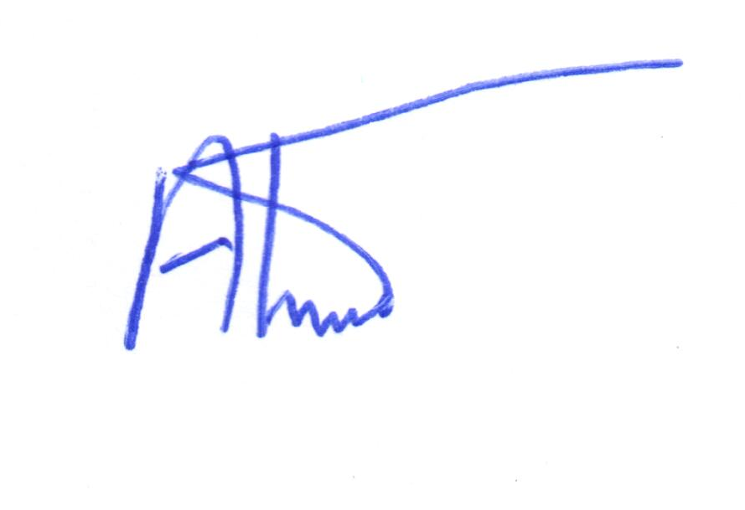 |  | Signature
Date | June 4th,2024 |  | Date

